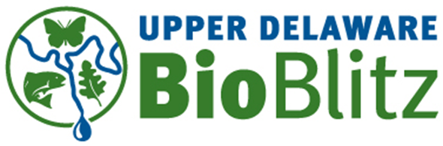

2014 Upper Delaware BioBlitz
Site Selection Nominations
The site for the 2014 Upper Delaware BioBlitz will be chosen by the BioBlitz Steering Committee based on sites nominated according to the attached process and criteria. Note that preference will be given in 2014 to sites in New York. The date of the event has not been set but will likely be late June or early July.
Please submit the following completed application for each site to info@upperdelawarebioblitz.com. Provide as much information as you can. You do not have to be the site owner to nominate a site.
The deadline for applications is October 31, 2013.
More information on the Upper Delaware BioBlitz is available at www.upperdelawarebioblitz.com

Site Name ___________________________________________________________________
Address
Street ___________________________________________________________________
Town ___________________________________________________________________
State ______________________________ Zip________________________________

Directions to the Site ___________________________________________________________________

Site Size (acres) ___________________________________________________________________
Brief summary of topography, vegetation, fauna and distinguishing characteristics
___________________________________________________________________
___________________________________________________________________
___________________________________________________________________
___________________________________________________________________
___________________________________________________________________
___________________________________________________________________

Site Nominator Name ___________________________________________________________________
Nominator Email ___________________________________________________________________
Nominator Phone ___________________________________________________________________
Site Owner (if different) ___________________________________________________________________
Owner Contact Info ___________________________________________________________________

Please attach a site map and any other information you might think is useful for the Site Selection Committee
Site Selection Process
- The BioBlitz Steering committee is seeking site nominations starting October 1 and ending October 31 from a variety of individuals, organizations and land owners.
- To nominate the site the nominator must provide a site address, site map, directions to the site, ownership information and site characteristics including size in acres and a brief summary of topography, vegetation, fauna and distinguishing characteristics.
- During the month of November a site selection subcommittee of the Steering Committee will evaluate the nominated sites and arrange to make preliminary site visits.
- By December 1, the subcommittee will make recommendations to the full Steering committee of the top three sites by order of preference.
- If required, other members of the Steering Committee will be able to make site visits to the top three sites during the month of December.
- The Steering Committee will choose the site by consensus by the end of December, 2013.
Site Selection Criteria
Must Haves
- Upper Delaware River Watershed location, even years in New York, odd years in Pennsylvania
- The site must be at least 50 acres in area and no more than 200 acres. A site may be a demarcated portion of a larger property.
- Uplands, lowlands, flowing water with small streams as well as large watercourses, impoundments, wetlands, forested and open pastures or meadows.
- Forested areas should include mature mixed deciduous hardwoods and evergreens as wells as transitional early successional forest
- Good access and egress from commonly traveled roads convenient to the Upper Delaware community
- Meadows for tents, camping and other infrastructure
- Onsite areas for parking or convenient shuttle parking
Nice-to-haves
- Adjacent to or near Delaware River and in NPS UDSRR corridor
- Onsite electricity, internet access, bathrooms and running water
- Onsite structures for programs and the base camp collection area
- Conservation strategy planned or in place
- Some agricultural or forest industry use
- Site contains special natural, environmental, cultural or historical attributes
- Other compatible public events onsite or nearby at the same time as the BioBlitz to leverage public attendance

